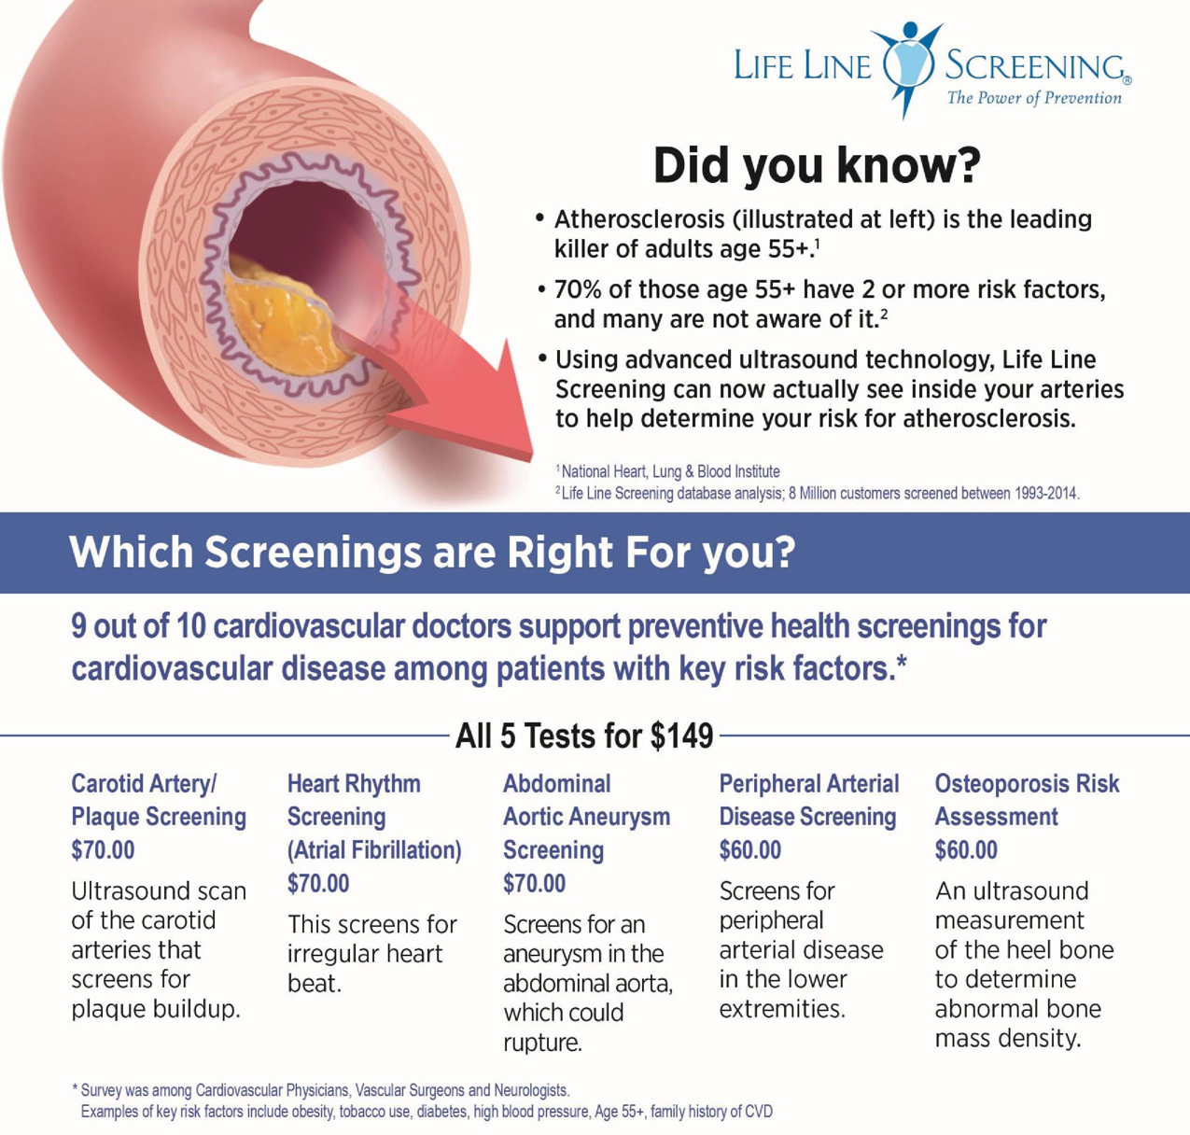

80% of strokes are preventable – are you at risk?

Wednesday May 5TH

Beekman Community Center

31 Recreation Center Rd

**SAVE $10 WITH PRIORITY CODE “HEFY” = $139**

**1-800-679-5609**



Bindex® **NEW** Ultrasound Technology scans the shin bone to determine abnormal bone density.